Drawing with the Library of Functions
By ( )
Student’s Name
Professor’s Name
Course
Date

Drawing with the Library of Functions.
- $f\left(x\right)=x \{0<x<2\}$
Solution

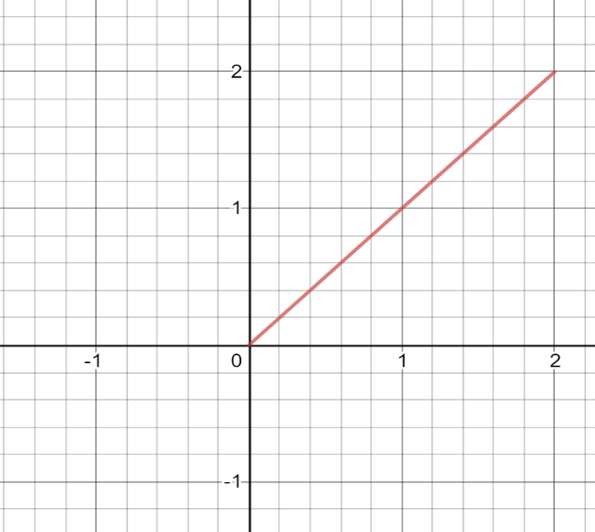
This is the original image generated.

Transformations
Having equation
y=af (b (x-c)) +d
Taking a= -1, b= 0.5, c= 0 and d=0
We get

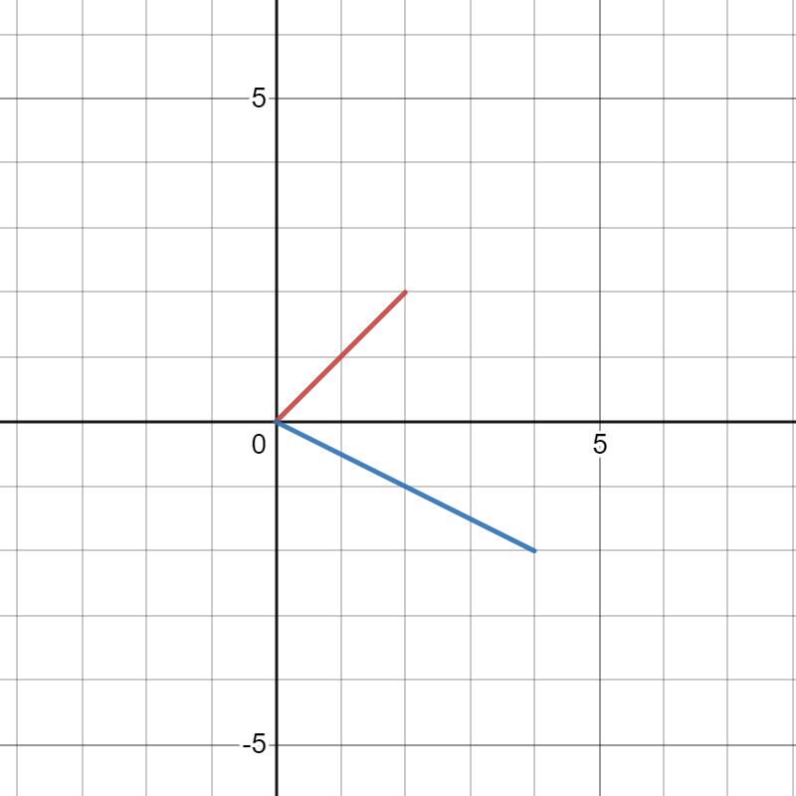

The new image is on the opposite side where (A = -1) then having (b =0.5) the image is stretched twice and having (c = 0 and d = 0). The line starts and ends the same point.
On the same image letting
x=f(y)
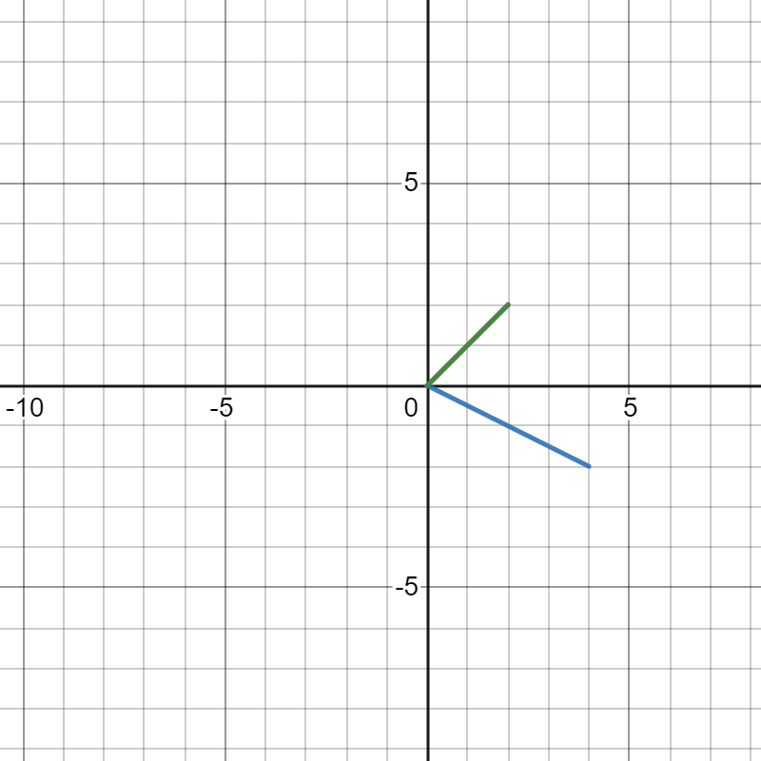

The image will be on the same position with the original one. Having no transformations.

- f(x)=x^{2}{0<x<2}
Solution

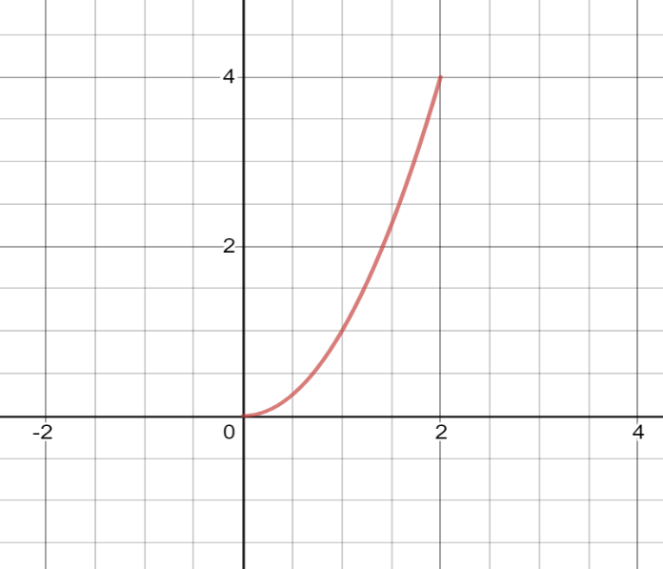
This is the original image generated.

Transformations

Having equation
y=af (b (x-c)) +d
Taking
a=-1
b=1
c=0
d=0
x=f(y)
We get

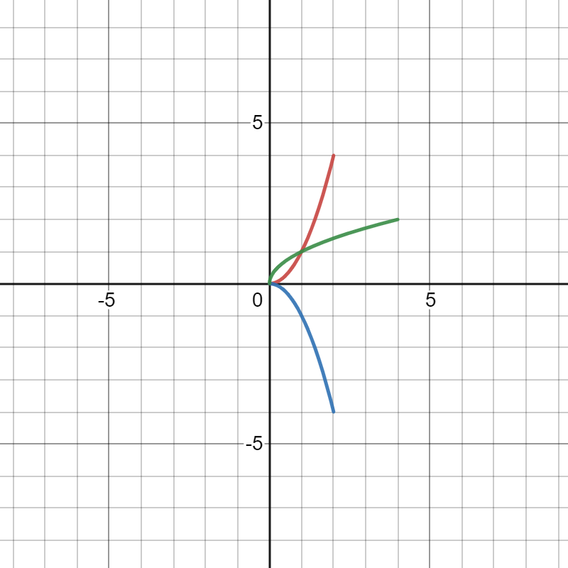
The green image is the transformation when x=f(y).it is the same stretched the same distance as the original image but it is generated on the opposite direction.
Having the (A = -1 and B = 1) the image is reflected on the opposite direction having the same but opposite co-ordinates. Having (c= 0 and d =0) the image starts the same point as the original one.

- f(x)=x^{3}{0<x<2}

Solution

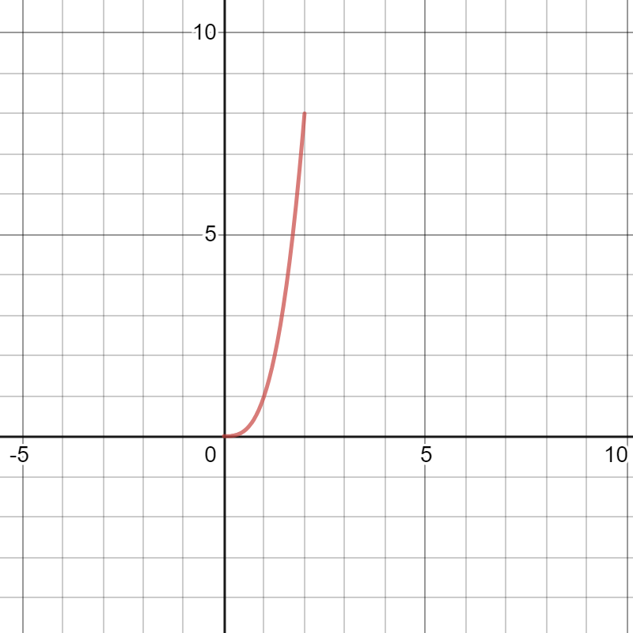
This is the original image generated.

Transformations
Having
y=af (b (x-c)) +d
a=-1
b=1
c=0
d=0
x=f(y)

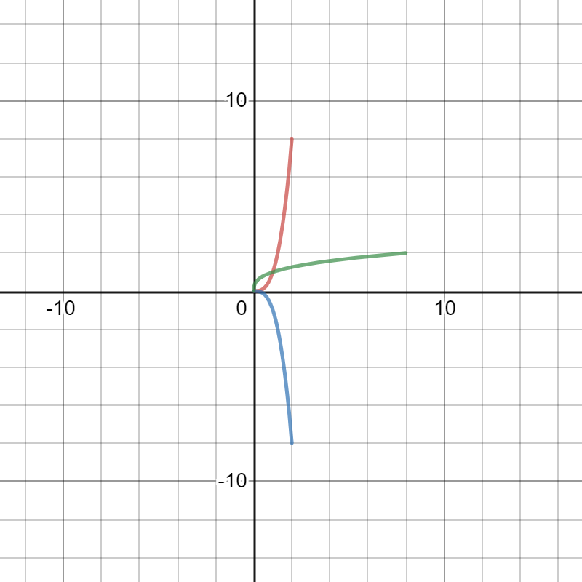
The green image is the transformation when x=f(y).it is the same stretched the same distance as the original image but it is generated on the opposite direction.
Having the (A = -1 and B = 1) the image is reflected on the opposite direction having the same but opposite co-ordinates. Having (c= 0 and d =0) the image starts the same point as the original one.

- f(x)=sqrt{x} {0<x<2}
Solution

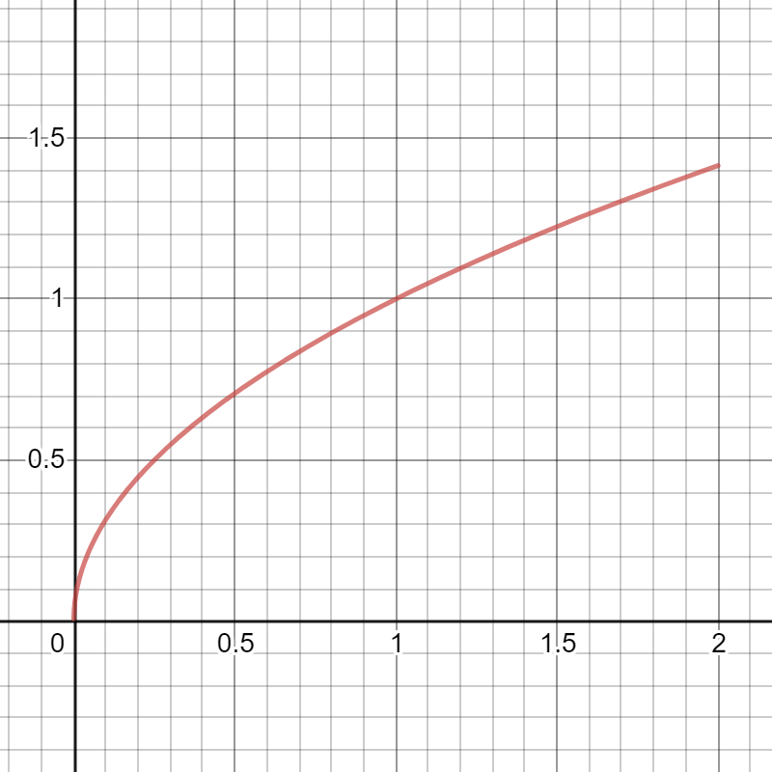
This is the original image generated.

Transformations
Having
y=af (b (x-c)) +d
a=-1
b=0.5
c=0
d=0
x=f(y)
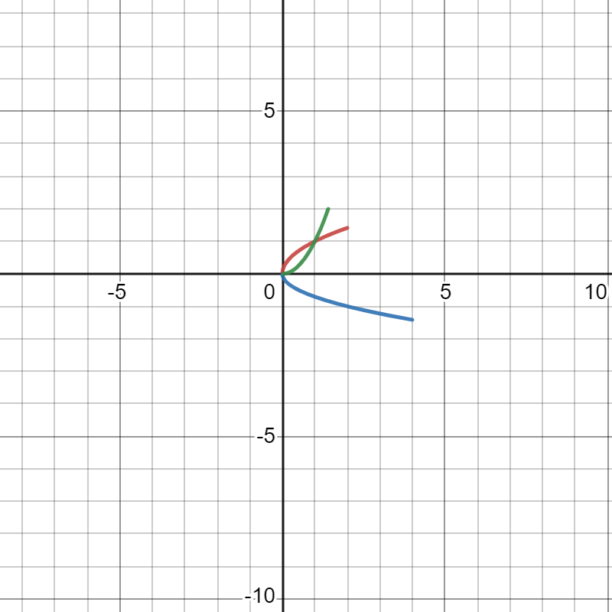
Having (a = -1) the image will be reflected 90 degrees on the opposite right side. Having (b = 0.5) the imaged will be stretched twice. Having (c = 0 and d = 0) the image will have the same starting point on both axis.
The green image is the transformation when x=f(y).it is the same stretched the same distance as the original image but it is generated on the opposite direction.

- F(X)=X^{1}/{3} {0<X<2}
Solution
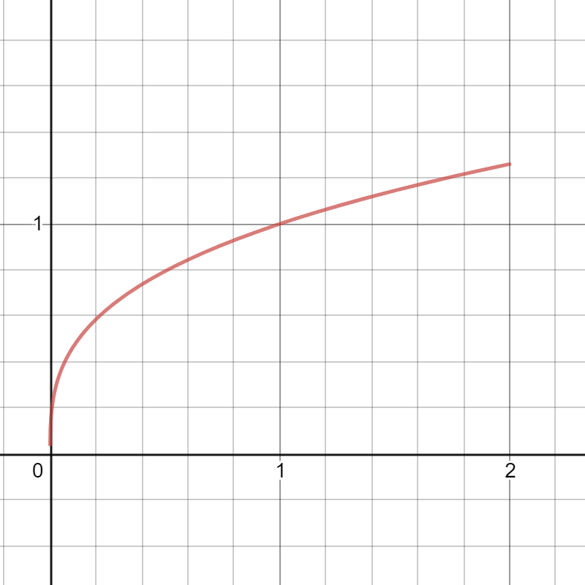
This is the original image generated.

Transformations
Having
y=af (b (x-c)) +d
a=-1
b=2
c=0
x=f(y)

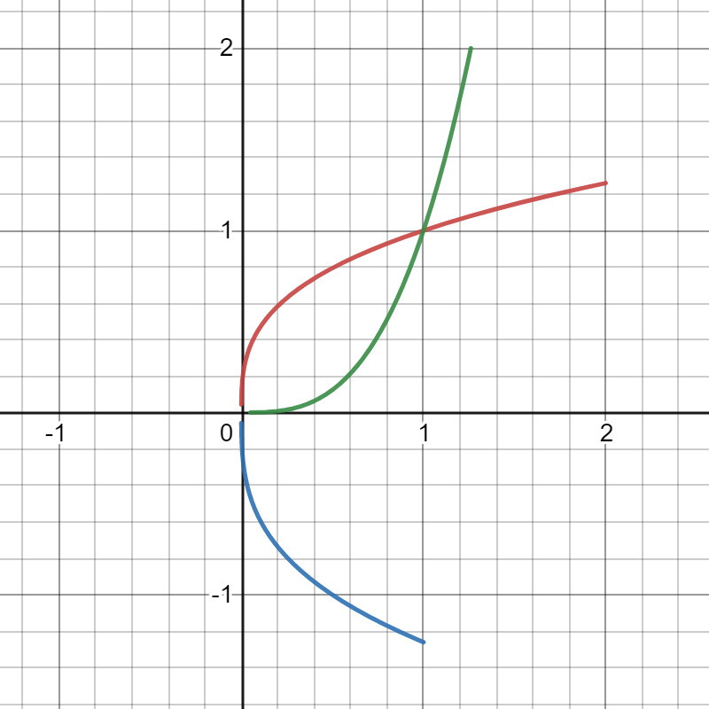

Having (a = -1) the image will be reflected 90 degrees on the opposite right side. Having (b =2) the imaged will have to shrink half of the original image. Having (c = 0 and d = 0) the image will have the same starting point on both axis.
The green image is the transformation when x=f(y).it is the same stretched the same distance as the original image but it is generated on the opposite direction.

- $f\left(x\right)=\frac{1}{x}$ {0<X<2}

Solution
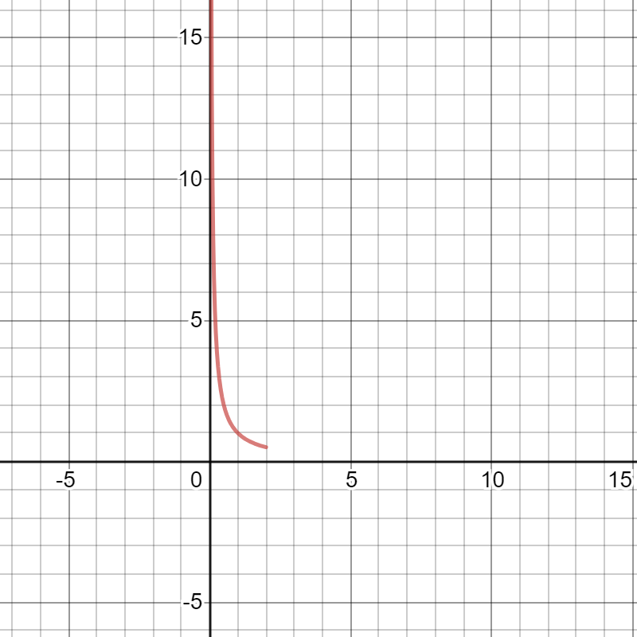
This is the original image generated.

Transformations
Having
y=af (b (x-c)) +d
a=-1
b=1
c=0
d=0

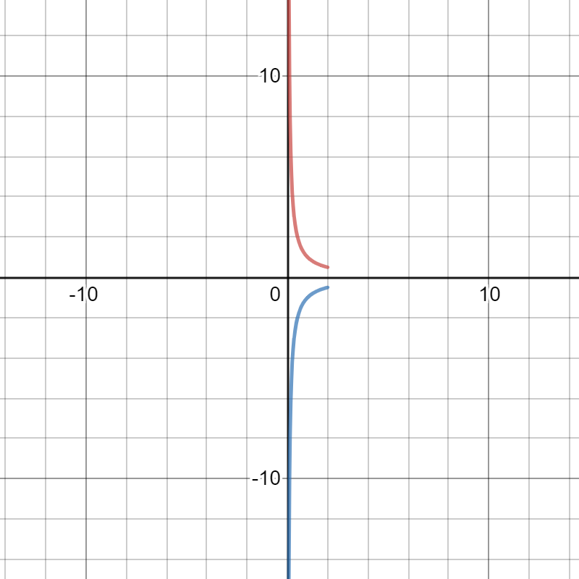
Having (a = -1) the image will be reflected 90 degrees on the opposite right side. Having (b =1) the imaged will have no shrinking or stretching. Having (c = 0 and d = 0) the image is reflected on the opposite side having different originally points.

Assuming
x=f(y)

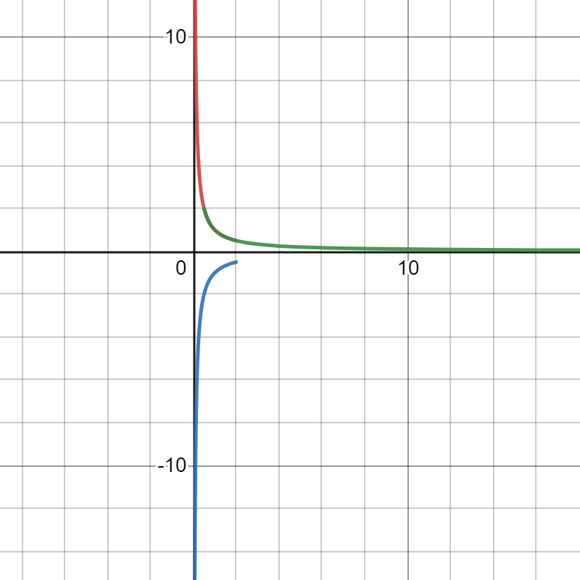
The image will be reflected 90 degrees on the right side. Having the same originally points as the original image.

G. f(x) =$\left|x\right|$ {0<x<2}
Solution
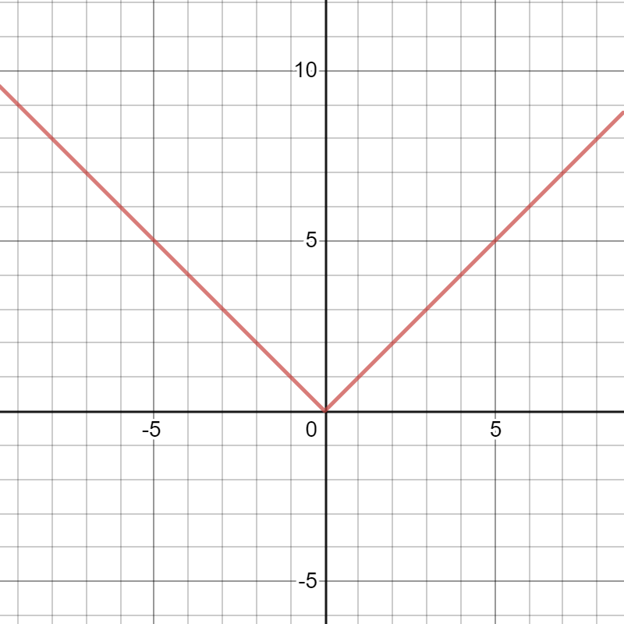
This is the original image.
Transformations
Having
F(x) =|x|
y=af (b (x-c)) +d
a=1
c=3.3
d=2.7
F(x) =3|x-c|+d
F(x) =af|x-2|+d
F(x) = - |x-c|+d
F(x) =af |x-c|+7
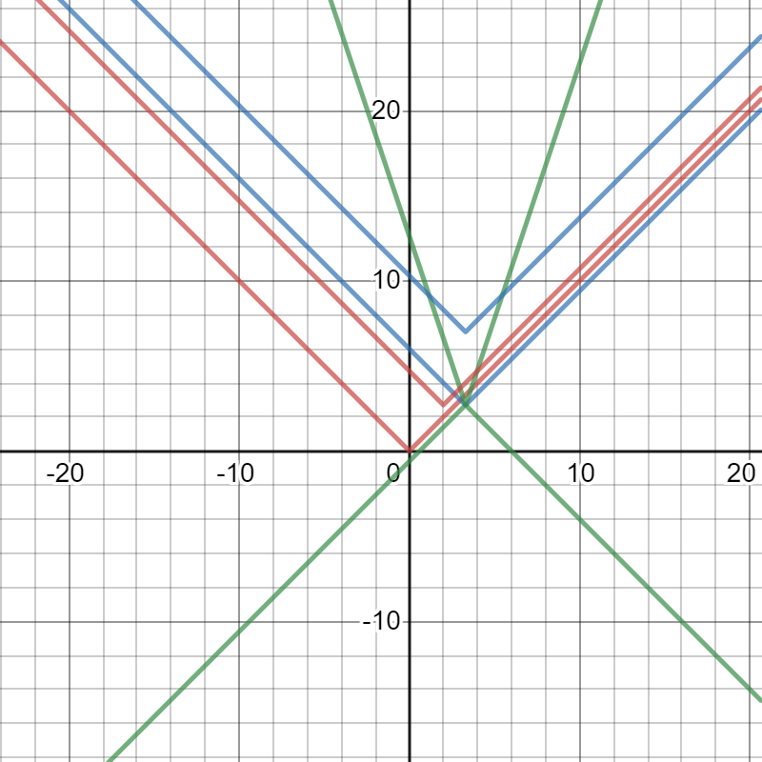

When AF is more than l1l, then there is a vertical stretch, if A is between 0 and 1, there is a vertical shrink. When A is negative, then the graph is reflected over y=d. When C is increased, the graph translates left, and decrease right. If d is increased, then the graph translates d units up, and d units down when it decreases.

h. $f\left(x\right)=⟦x⟧$ (greatest integer less than x) [floor(x)]
Solution

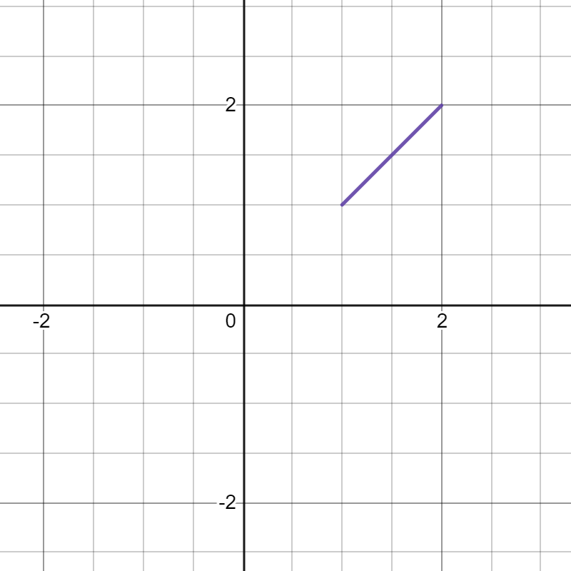
This is the original image.
Transformations
Having
y=af (b (x-c)) +d
a=-1
b=1
c=0
d=0
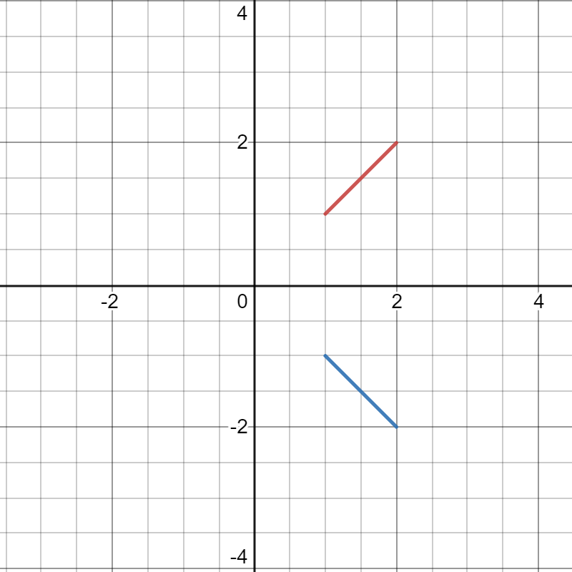
Having the (A = -1 and B = 1) the image is reflected on the opposite direction having the same but opposite co-ordinates. Having (c= 0 and d =0) the image starts the same point as the original one.

Letting
x=f(y)
We will have
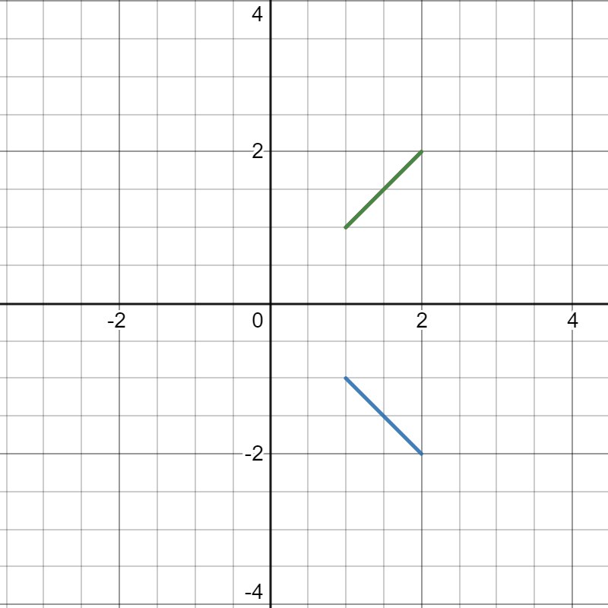
The image will be on the same position with the original one having the green color. Having no transformations.

NB: Hello my friend. Remember to delete this part before you submit your work.
Please take a look at this work and see if it meets your expectations. If so, I request you to kindly remember to release the funds on time and leave a 10-star rating if you do not mind. I will really appreciate it. Also, you can find me on this mail (davykikuvi774@gmail.com) for more work in future if you will need my services. Feel free and let me know. I will always be at your service whenever I can. Again, thank you for working with me.

